LDAP - Apache Directory Studio: A Basic Tutorial

In this tutorial we will setup a basic LDAP structure containing users and roles. We will be using the excellent Apache Directory Studio IDE. This tutorial will be the basis for our other Spring LDAP integration tutorials.  
  
**What is Apache Directory Studio?**

The Eclipse based LDAP browser and directory client  
  
Apache Directory Studio is a complete directory tooling platform intended to be used with any LDAP server however it is particularly designed for use with ApacheDS. It is an Eclipse RCP application, composed of several Eclipse (OSGi) plugins, that can be easily upgraded with additional ones. These plugins can even run within Eclipse itself.  
  
Source: http://directory.apache.org/studio/

**What is LDAP?**

The Lightweight Directory Access Protocol (LDAP) is an application protocol for reading and editing directories over an IP network. A directory is an organized set of records. For example, the telephone directory is an alphabetical list of persons and organizations, with each record having an address and phone number. A directory information tree often follows political, geographic, or organizational boundaries. LDAP directories often use Domain Name System (DNS) names for the highest levels. Deeper inside the directory might appear entries for people, departments, teams, printers, and documents.  
  
Source: http://en.wikipedia.org/wiki/LDAP

If this is your first time to LDAP, you might be wondering how is this different from an RDBMS. I suggest my readers to visit the following article [Should I Use a Directory, a Database, or Both?](http://support.novell.com/techcenter/articles/ana20011101.html)  
  
**A Brief Background**  
We have a small startup company named *Mojo Enterprises*. We have four people, and two of them are admins. Our task is to create a hierarchical structure of our organization using LDAP because we anticipate the eventual growth of the company. We may have hundreds of people from different departments in five years time. Each has their own information and structure. These information and structure will be shared among different applications of the company. LDAP is a good protocol to meet all these requirements.  
  
**Layout the Structure**  
Let's define the important elements of the company.  
  
*Company Name:* Mojo Enterprises   
*Members:*

* Hugo Williams
* John Keats
* John Milton
* Robert Browning

*Admins:*

* Hugo Williams
* John Keats

LDAP is a hierarchical tree structure, so our design will be influenced by that.  
  
We need to assign the topmost parent of our structure. Logically, the name of the company fits that requirement. We'll pick the name *mojo* as the topmost parent.  
  
Under the *mojo* we will assign our members. There are many ways to organize our members. We can organize them by gender, by job function, and etc. For this tutorial we'll organize them based on identity and roles. We'll put all the identities of each person in a separate element, while the roles will be placed on another element.  
  
Under the roles we have two sub-divisions. Remember we have the regular users and the admins. What we'll do is divide the roles into elements.   
  
Here's how our structure would like:

mojo

|

|--roles

| |

| |--admin

| |--regular

|

|--identities

|

|--guy1

|--guy2

|--guy3

|--guy4

We'll make the names a little bit formal, and make it conform with the naming convention of LDAP. For the topmost parent, we'll retain *mojo*. For *roles*, we'll use *groups* instead. For *identities*, we'll use *users*  
  
When we're done with this tutorial, we should have the following structure:

[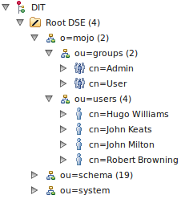](http://3.bp.blogspot.com/_hHhKKxOZVSc/TR8dbPCRafI/AAAAAAAAAVI/AYWTCZV37ug/s1600/final.png)

It's really simple to do. All you need is an Apache Directory Studio, this tutorial, and patience.   
  
**Install the Apache Directory Studio**  
Before we can do any LDAP-related work, we need to have an IDE first. Although it's not required, we'll require it for this tutorial. And why not? It's free anyway.   
  
To install the Apache Directory Studio, visit the following link *http://directory.apache.org/studio/downloads.html* Follow the instructions on that link   
for the installation steps.  
  
**Create a New Server**  
Once you have installed the studio, we need to create a server. Here are the steps:  
  
1. Open Apache Directory Studio.

3. Go to File, and click New. A popup window will open.  
  
4. Expand the Apache DS folder, and select the Apache DS Server

[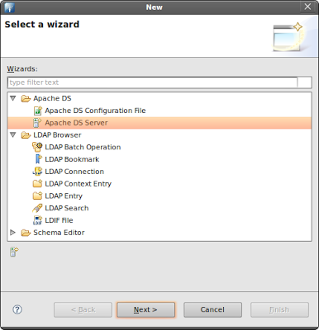](http://2.bp.blogspot.com/_hHhKKxOZVSc/TR8m78sd0fI/AAAAAAAAAVY/CAnFxn8Bmrw/s1600/new-server.png)

5. Click Next.  
  
6. Type-in any name for the server. For example, apache-ds-server  
  
7. Click Finish.   
  
8. A new server has been added on your Servers panel.   
If you can't see the Servers panel, go the menu bar then click Window > Show View > Apache DS > Servers

[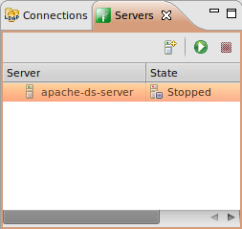](http://4.bp.blogspot.com/_hHhKKxOZVSc/TR8nb85nhPI/AAAAAAAAAVg/xcTB_fnXUHs/s1600/server-panel.png)

9. Select your server, then click the Run button.  
Your server should now be running.   
  
**Create a Connection**   
To browse the contents of the server, we need to create a connection. Here are the steps:  
  
1. Right-click on your server.   
  
2. Select LDAP Browser  
  
3. Select Create a Connection. An alert message will popup indicating the a new connection has been created.

[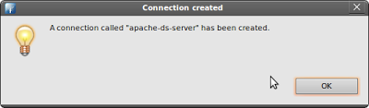](http://3.bp.blogspot.com/_hHhKKxOZVSc/TR8olGvplII/AAAAAAAAAVo/6e6LHt0u60g/s1600/Screenshot-Connection%2Bcreated%2B.png)

4. Go to the Connections panel.  
If you can't see the Connections panel, go the menu bar then click Window > Show View > LDAP Browser > Connections

[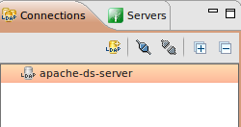](http://1.bp.blogspot.com/_hHhKKxOZVSc/TR8o5IFrpyI/AAAAAAAAAVw/l5T9T_5__zo/s1600/connections-panel.png)

5. Double-click the name of the new connection you've created earlier.  
  
6. The LDAP Browser panel should refresh and show the contents of the server.  
Notice the topmost entry of this server is *DIT*, followed by the *Root DSE*.

[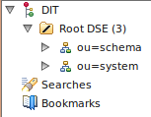](http://3.bp.blogspot.com/_hHhKKxOZVSc/TR8pU73GgvI/AAAAAAAAAV4/PSaGmUK7gzo/s1600/new-ldap-browser.png)

7. Expand the Root DSE folder. There are two sub-entries: ou=schema and ou=system.  
These are partitions in the server. Do not modify them unless you know what you're doing.   
  
**Create a New Partition**  
To add our company to the root tree, we need to create a new partition. Everything related to the company will be attached to this new partition. Here are the steps:  
  
1. Go to the Servers panel, and right-click your server.   
  
2. Select *Open Configuration*. A *server.xml* editor will appear on the main panel.

[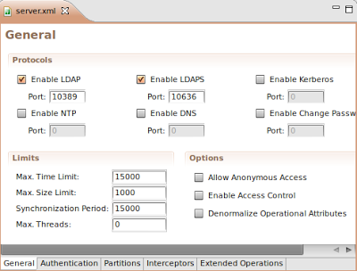](http://3.bp.blogspot.com/_hHhKKxOZVSc/TR8rdkjHyHI/AAAAAAAAAWA/OHdYjAgbChI/s1600/server-xml.png)

3. At the bottom part of server.xml, there are five tabs. Click the Partitions tab.  
The Partitions tab should appear.   
  
4. Click on Add and enter the following details for this new partition.  
  
ID: mojo  
Cache Size: 100  
Suffix: o=mojo  
  
5. Save your changes (CTRL + S). A new partition has been added.

[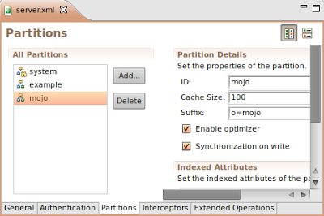](http://4.bp.blogspot.com/_hHhKKxOZVSc/TR8sNxJLF2I/AAAAAAAAAWI/fO25HMauWVg/s1600/partitions-tab.png)

6. Restart your Apache DS server.  
  
7. Refresh the LDAP Browser panel.   
  
8. Click on the Root DSE folder. A new editor will open containing the details of this folder.

[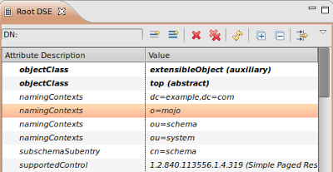](http://1.bp.blogspot.com/_hHhKKxOZVSc/TR8s4MVfbgI/AAAAAAAAAWQ/bhXERjuKdZk/s1600/root-dse-editor.png)

Notice the *namingContexts* attribute. The namingContexts **o=mojo** shows in the lists. However it doesn't show under the *Root DSE* tree because we need to add the *organization* manually in the tree.  
  
**Add the Parent Organization**  
Our company is an organization. In LDAP, to represent a company we use the *organization* object which is represented by the alias *o*. So if our company's name is *mojo*, the *Distinguished Name* (dn) of the company is *o=mojo*. It's a naming convention. (The *Distinguished Name* is like the primary key or primary identity).  
  
To create the **organization** object, follow the steps below:  
1. Right-click on the *Root DSE* folder. Select *New*. Select *New Context Entry*  
  
2. Select *Create entry from scratch*. Click Next. The Object classes window will appear.  
  
3. Find the *organization* object. Select it then click *Add*

[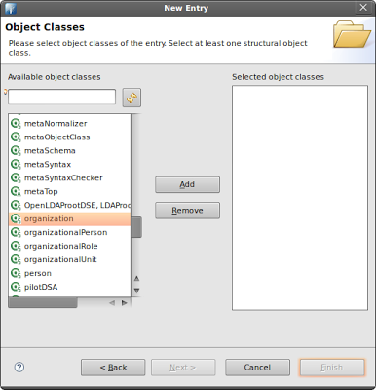](http://4.bp.blogspot.com/_hHhKKxOZVSc/TR8ukYnx93I/AAAAAAAAAWY/boc6GEMAehk/s1600/object-window%2B.png)

4. Click *Next*. Now you need to enter a *Distinguished Name* (dn). Click on the pulldown menu. Select *o=mojo*.

[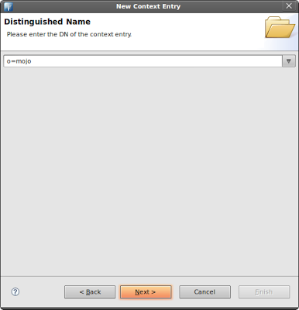](http://2.bp.blogspot.com/_hHhKKxOZVSc/TR8v-SHL0TI/AAAAAAAAAWo/XrgPqXkTc20/s1600/dn-pulldown.png)

5. Click *Next*. The *Attributes* window will appear. Examine the values.   
  
6. Click *Finish*. Notice the new partition now appears under the *Root DSE*.

[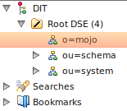](http://4.bp.blogspot.com/_hHhKKxOZVSc/TR8wbJDSZGI/AAAAAAAAAWw/jqhD-7RFpbk/s1600/mojo-now-appears.png)

**Add the Organizational Units**  
Earlier we mentioned we'll structure our company based on *users* (contains personal information of the user) and *groups* (contains the authorization level of each person).  
Both of these represent an organizational unit.   
  
In LDAP, to represent an organizational unit we use the *organizationalUnit* object which is represented by the alias *ou*. So if we have a unit name *users*, the *Distinguished Name* (dn) is *ou=users,o=mojo*. Why is there an *o=mojo*? It's a naming convention. The same convention applies to *groups*. The *Distinguished Name* (dn) is *ou=users,o=mojo*. This can be likened the way we name URLS. For example, users.mojo.com or groups.mojo.com.   
  
We'll add first the *users* unit. Here are the steps:  
1. Go to the *LDAP Browser* panel. Expand the *Root DSE* folder.  
  
2. Right-click the *o=mojo* entry. Select *New*. Select *New Entry*.  
The *Entry Creation Method* window will appear.

[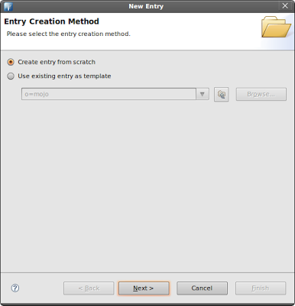](http://4.bp.blogspot.com/_hHhKKxOZVSc/TR8y5KDywDI/AAAAAAAAAW4/MZ28JOZiqMI/s1600/entry-creation-method.png)

3. Select *Create entry from scratch*. Click *Next*. The *Object Classes* window will appear.  
  
4. Find the *organizationalUnit* object. Select it then click *Add*.

[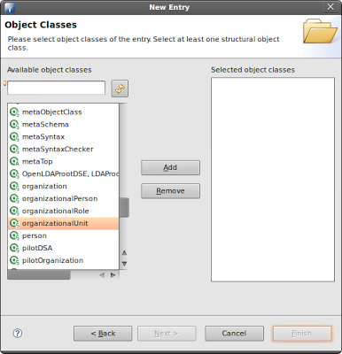](http://1.bp.blogspot.com/_hHhKKxOZVSc/TR8zSH5rJJI/AAAAAAAAAXA/Kq2tM1kg4EU/s1600/ou-object-add.png)

5. Click *Next*. Now you need to enter a *Distinguished Name* (dn).   
The *Parent* field should read *o=mojo*.

[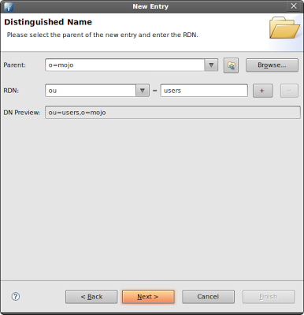](http://1.bp.blogspot.com/_hHhKKxOZVSc/TR8znZzyWUI/AAAAAAAAAXI/Ir1XUNN_etY/s1600/ou-users.png)

On the *RDN* field enter *ou*. On the value field enter *users*. The *DN Preview* should read *ou=users,o=mojo*  
  
6. Click *Next*. The *Attributes* window will appear. Examine the values.   
  
7. Click *Finish*. We've just created the *ou=users* organizational unit.

[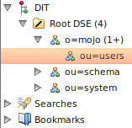](http://3.bp.blogspot.com/_hHhKKxOZVSc/TR80JFDNBjI/AAAAAAAAAXQ/S1c0_ZzAQCI/s1600/ou-users-ldap-browser.png)

**Add the Second Organizational Units**  
We've just added the *ou=users* organizational unit. We need to add the organizational unit for *groups* as well. We'll follow the same steps.  
  
1. Go to the *LDAP Browser* panel. Expand the *Root DSE* folder.  
  
2. Right-click the *o=mojo* entry. Select *New*. Select *New Entry*.  
The *Entry Creation Method* window will appear.  
  
3. Select *Create entry from scratch*. Click *Next*. The *Object Classes* window will appear.  
  
4. Find the *organizationalUnit* object. Select it then click *Add*.  
  
5. Click *Next*. Now you need to enter a *Distinguished Name* (dn).   
The *Parent* field should read *o=mojo*.

[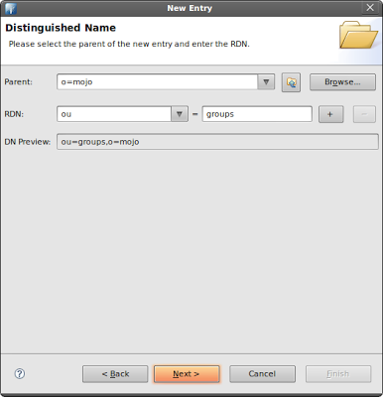](http://1.bp.blogspot.com/_hHhKKxOZVSc/TR80_2z0eEI/AAAAAAAAAXY/U03T-LsLsg0/s1600/ou-groups-dn.png)

On the *RDN* field enter *ou*. On the value field enter *groups*. The *DN Preview* should read *ou=groups,o=mojo*  
  
6. Click *Next*. The *Attributes* window will appear. Examine the values.   
  
7. Click *Finish*. We've just created the *ou=groups* organizational unit.

[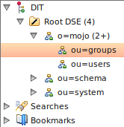](http://2.bp.blogspot.com/_hHhKKxOZVSc/TR81eQa7onI/AAAAAAAAAXg/JknadzEqozE/s1600/ou-groups-ldap-browser.png)

**Add the Staff**  
Now we need to add our four people:

* Hugo Williams
* John Keats
* John Milton
* Robert Browning

*Admins:*

* Hugo Williams
* John Keats

We'll place their personal information under the *ou=users*; whereas we'll place their authorization levels under the *ou=groups*.  
  
Let's start with the *ou=users*. We'll be adding four persons. We'll represent each person using the *inetOrgPerson* object.  
  
What's an inetOrgPerson object?

The inetOrgPerson object class is a general purpose object class that  
holds attributes about people. The attributes it holds were chosen  
to accommodate information requirements found in typical Internet and  
Intranet directory service deployments.  
Source: http://www.faqs.org/rfcs/rfc2798.html

An *inetOrgPerson* can contain a user id (uid) and password (userPassword) which will be useful later for authenticating users from using LDAP.  
  
Here are the steps we need to do:  
1. Go to the *LDAP Browser* panel. Expand the *Root DSE* folder.  
  
2. Expand the *o=mojo* entry.  
  
3. Right-click the *ou=users* entry. Select *New*. Select *New Entry*.  
The *Entry Creation Method* window will appear.  
  
4. Select *Create entry from scratch*. Click *Next*. The *Object Classes* window will appear.  
  
5. Find *inetOrgPerson* object. Select it then click *Add*.

[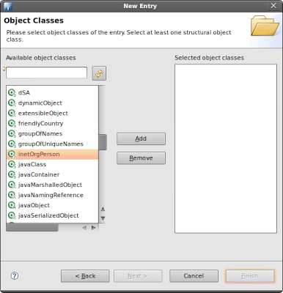](http://1.bp.blogspot.com/_hHhKKxOZVSc/TR85xM7DWxI/AAAAAAAAAXo/7kWhhBXHBzY/s1600/inetOrgPerson-add.png)

6. Click *Next*. Now you need to enter a *Distinguished Name* (dn).   
The *Parent* field should read *ou=users,o=mojo*.

[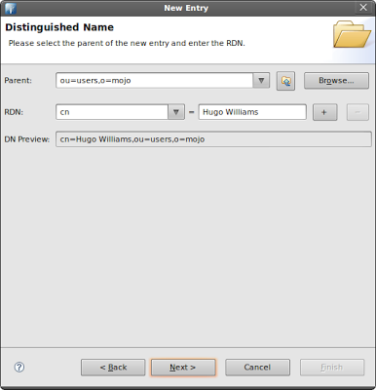](http://4.bp.blogspot.com/_hHhKKxOZVSc/TR86R7evH5I/AAAAAAAAAXw/qBVX51ucxz0/s1600/dn-cn-hugo.png)

On the *RDN* field enter *cn*. On the value field enter *Hugo Williams*.  
The *DN Preview* should read *cn=Hugo Williams,ou=users,o=mojo* (cn represent Common Name).  
  
7. Click *Next*. The *Attributes* window will appear. Examine the values.   
  
8. Under the *sn* attribute, enter *Williams* (sn stands for Surname)

[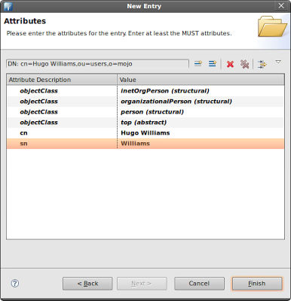](http://3.bp.blogspot.com/_hHhKKxOZVSc/TR862BfN5BI/AAAAAAAAAX4/tL1AdjOtx50/s1600/cn-hugo-attributes.png)

9. We need to add a username for this user. Right-click on the same window. Select *New Attribute*. The *Attribute Type* window will appear.  
  
10. On the *Attribute* type field, enter *uid*. This will serve as the username of the person.

[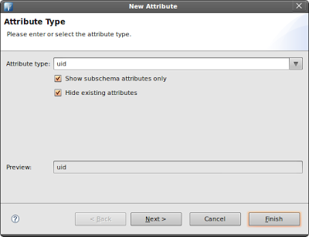](http://1.bp.blogspot.com/_hHhKKxOZVSc/TR87VHKXo9I/AAAAAAAAAYA/xnmCzoQjRRI/s1600/username-uid.png)

11. Click *Next*, then click *Finish*.  
  
12. You're back on the *Attributes* window. On the *uid* attribute value, enter *hwilliams*

[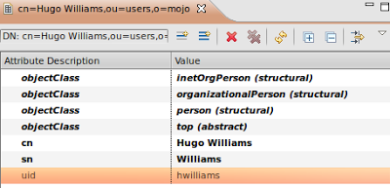](http://1.bp.blogspot.com/_hHhKKxOZVSc/TR87xa-mn5I/AAAAAAAAAYI/Jh--ECYPlvY/s1600/user-uid.png)

13. We need to add a password for this user. Right-click on the same window. Select Ne*w Attribute*. The Attribute Type window will appear.  
  
14. On the *Attribute* type field, enter *userPassword*. This will serve as the password of the person.  
  
15. Click *Next*, then click *Finish*.  
  
16. You will be asked to enter a password. Enter *pass* as the new password. Make sure that the *Select Hash Method* is set to *Plaintext*

[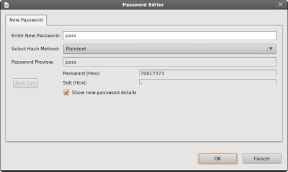](http://1.bp.blogspot.com/_hHhKKxOZVSc/TR88VbUae5I/AAAAAAAAAYQ/8jIi0_bsn-c/s1600/new-password.png)

17. Click *OK*.

[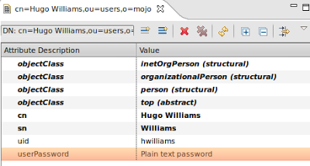](http://2.bp.blogspot.com/_hHhKKxOZVSc/TR89VMU4s2I/AAAAAAAAAYg/7jiBlLI9_Ck/s1600/cn-hugo-details.png)

A new entry has been added under the *ou=users*. The new entry is *cn=Hugo Williams*.

[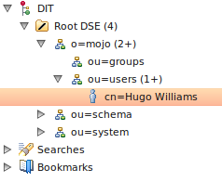](http://3.bp.blogspot.com/_hHhKKxOZVSc/TR89HHedh3I/AAAAAAAAAYY/t4QhmyEtH6c/s1600/ldap-browser-hugo.png)

Now we need to add the remaining three users. In order to do that, just repeat the same steps earlier. Here are the details of the three remaining users.

Name: John Keats

uid: jkeats

userPassword: pass

Name: John Milton

uid: jmilton

userPassword: pass

Name: Robert Browning

uid: rbrowning

userPassword: pass

**Add the Authorization Levels**  
We have added the personal information, as well as the usernames and passwords, for each person under the *ou=users*. Now, we will be adding the authorization level for each of these persons.  
  
We'll add them under *ou=groups*. We'll use the *groupOfUniqueNames* object to represent each role.  
  
Let's add the *User* role first.  
1. Go to the *LDAP Browser* panel. Expand the *Root DSE* folder.  
  
2. Expand the *o=mojo* entry.  
  
3. Right-click the *ou=groups* entry. Select *New*. Select *New Entry*.  
The *Entry Creation Method* window will appear.  
  
4. Select *Create entry from scratch*. *Click Next*. The *Object Classes* window will appear.  
  
5. Find the *groupOfUniqueNames* object. Select it then click *Add*.

[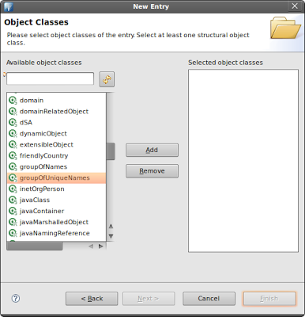](http://1.bp.blogspot.com/_hHhKKxOZVSc/TR8_yknJ8MI/AAAAAAAAAYo/JDivhZelISg/s1600/object-groupOfUniqueNames.png)

6. Click *Next*. Now you need to enter a *Distinguished Name* (dn).   
The *Parent* field should read *ou=groups,o=mojo*.

[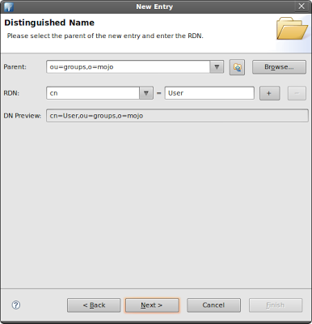](http://4.bp.blogspot.com/_hHhKKxOZVSc/TR9AFwOjkhI/AAAAAAAAAYw/JAd6eRkccbA/s1600/dn-user.png)

On the *RDN* field enter *cn*. On the value field enter *User*  
The *DN Preview* should read *cn=User,ou=groups,o=mojo*  
  
8. Click *Next*. The *Attributes* window will appear. Examine the values.

[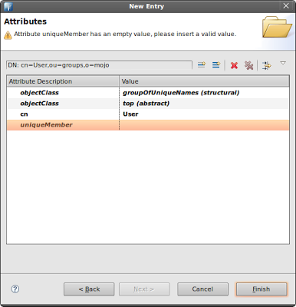](http://2.bp.blogspot.com/_hHhKKxOZVSc/TR9AofyX4OI/AAAAAAAAAY4/t9NSvQit4vE/s1600/attributes-user.png)

Notice there's a *uniqueMember* attribute. We'll be placing the *Distinguished Name* (dn) of our users in this entry. One *uniqueMember* attribute will represents one user. This means we need to add three more *uniqueMember* attributes for a total of four *uniqueMember* attributes.  
  
9. Right-click on the same window. Select *New Attribute*. The *Attribute Type* window will appear.  
  
10. On the *Attribute* type field, enter *uniqueMember*.   
  
11. Click *Next*, then click *Finish*.  
  
12. We're back on the *Attributes* window. We need to add two more *uniqueMembers* (for a total of four *uniqueMembers*). Repeat the same steps for adding an attribute.  
  
13. Now we need to fill-in the values for these attributes. In each entry add the *dn* of each user. Here are the *Distinguished Name* for each user.

cn=Hugo Williams,ou=users,o=mojo

cn=John Keats,ou=users,o=mojo

cn=John Milton,ou=users,o=mojo

cn=Robert Browning,ou=users,o=mojo

[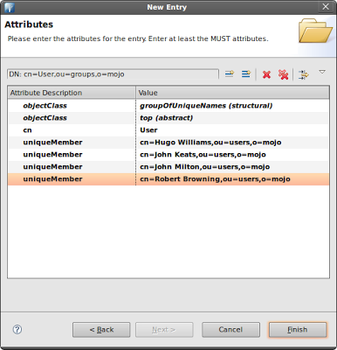](http://2.bp.blogspot.com/_hHhKKxOZVSc/TR9Bjk3CRMI/AAAAAAAAAZA/lnrsytsIlEE/s1600/4-uniquemembers.png)

14. Click *Finish* when you're done.  
  
A new entry has been added under the *ou=groups*. The new entry is *cn=User*

[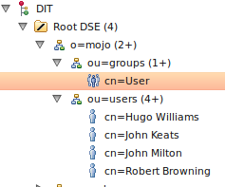](http://3.bp.blogspot.com/_hHhKKxOZVSc/TR9CoALBMII/AAAAAAAAAZI/lJxsuAcDG-U/s1600/userRole.png)

Now we need another entry for the Admin role. We'll repeat the same steps.   
1. Go to the *LDAP Browser* panel. Expand the *Root DSE* folder.  
  
2. Expand the *o=mojo* entry.  
  
3. Right-click the *ou=groups* entry. Select *New*. Select *New Entry*.  
The *Entry Creation Method* window will appear.  
  
4. Select *Create entry from scratch*. *Click Next*. The *Object Classes* window will appear.  
  
5. Find the *groupOfUniqueNames* object. Select it then click *Add*.

[](http://1.bp.blogspot.com/_hHhKKxOZVSc/TR8_yknJ8MI/AAAAAAAAAYo/JDivhZelISg/s1600/object-groupOfUniqueNames.png)

6. Click *Next*. Now you need to enter a *Distinguished Name* (dn).   
The *Parent* field should read *ou=groups,o=mojo*.   
  
On the *RDN* field enter *cn*. On the value field enter *Admin*  
The *DN Preview* should read *cn=Admin,ou=groups,o=mojo*  
  
7. Click *Next*. The *Attributes* window will appear. Examine the values.   
  
Notice there's a *uniqueMember* attribute. We'll be placing the *Distinguished Name* (dn) of our users in this entry. One *uniqueMember* attribute will represent one user. This means we need to add one more *uniqueMember* attributes for a total of two *uniqueMember* attributes.  
  
8. Right-click on the same window. Select *New Attribute*. The *Attribute Type* window will appear.  
  
9. On the *Attribute* type field, enter *uniqueMember*.   
  
10. Click *Next*, then click *Finish*.  
  
11. We're back on the *Attributes* window. We need to add one more *uniqueMembers* (for a total of two *uniqueMembers*). Repeat the same steps for adding an attribute.  
  
12. Now we need to fill-in the values for these attributes. In each entry add the *dn* of each user. Here are the *Distinguished Name* for each user.

cn=Hugo Williams,ou=users,o=mojo

cn=John Keats,ou=users,o=mojo

[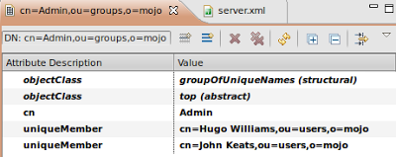](http://3.bp.blogspot.com/_hHhKKxOZVSc/TR9KkJltOWI/AAAAAAAAAZQ/3AB9jloF8Zw/s1600/admin-uniquemembers.png)

13. Click *Finish* when you're done.  
  
A new entry has been added under the *ou=groups*. The new entry is *cn=Admin*

[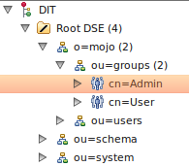](http://1.bp.blogspot.com/_hHhKKxOZVSc/TR9KwniZrwI/AAAAAAAAAZY/6fcQHkCw0NQ/s1600/admin-groups.png)

Here's the final structure:

[](http://3.bp.blogspot.com/_hHhKKxOZVSc/TR8dbPCRafI/AAAAAAAAAVI/AYWTCZV37ug/s1600/final.png)

**Exporting the Data**  
If you need to backup your data or replicate the information in your LDAP, you can export the data. When the data is exported, it's saved in *LDIF* format. This format is actually a human-readable file. Here's the LDIF for this tutorial:

version: 1

dn: o=mojo

objectClass: organization

objectClass: extensibleObject

objectClass: top

o: mojo

dn: ou=users,o=mojo

objectClass: extensibleObject

objectClass: organizationalUnit

objectClass: top

ou: users

dn: ou=groups,o=mojo

objectClass: extensibleObject

objectClass: organizationalUnit

objectClass: top

ou: groups

dn: cn=User,ou=groups,o=mojo

objectClass: groupOfUniqueNames

objectClass: top

cn: User

uniqueMember: cn=John Milton,ou=users,o=mojo

uniqueMember: cn=Robert Browning,ou=users,o=mojo

uniqueMember: cn=Hugo Williams,ou=users,o=mojo

uniqueMember: cn=John Keats,ou=users,o=mojo

dn: cn=Admin,ou=groups,o=mojo

objectClass: groupOfUniqueNames

objectClass: top

cn: Admin

uniqueMember: cn=Hugo Williams,ou=users,o=mojo

uniqueMember: cn=John Keats,ou=users,o=mojo

dn: cn=Robert Browning,ou=users,o=mojo

objectClass: organizationalPerson

objectClass: person

objectClass: inetOrgPerson

objectClass: top

cn: Robert Browning

sn: Browning

uid: rbrowning

userPassword:: cGFzcw==

dn: cn=John Keats,ou=users,o=mojo

objectClass: organizationalPerson

objectClass: person

objectClass: inetOrgPerson

objectClass: top

cn: John Keats

sn: Keats

uid: jkeats

userPassword:: cGFzcw==

dn: cn=Hugo Williams,ou=users,o=mojo

objectClass: organizationalPerson

objectClass: person

objectClass: inetOrgPerson

objectClass: top

cn: Hugo Williams

sn: Williams

uid: hwilliams

userPassword:: cGFzcw==

dn: cn=John Milton,ou=users,o=mojo

objectClass: organizationalPerson

objectClass: person

objectClass: inetOrgPerson

objectClass: top

cn: John Milton

sn: Milton

uid: jmilton

userPassword:: cGFzcw==

That's it. We've managed to setup our basic LDAP structure using Apache Directory Studio. We've also covered some of the popular LDAP objects.